Name: Rohitashav Aggarwal
Creating Domain Local and Global Security Group
- Launch AD users and Computers
- Click on the user tree in one of the regions you created
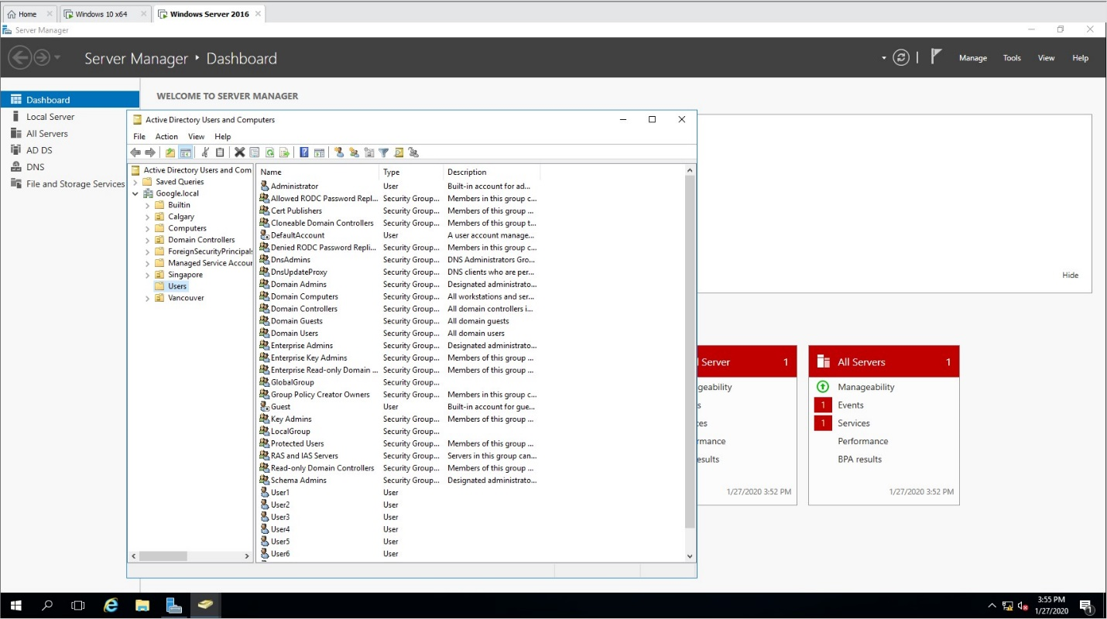
- Create a new group
- Choose Local Security Group
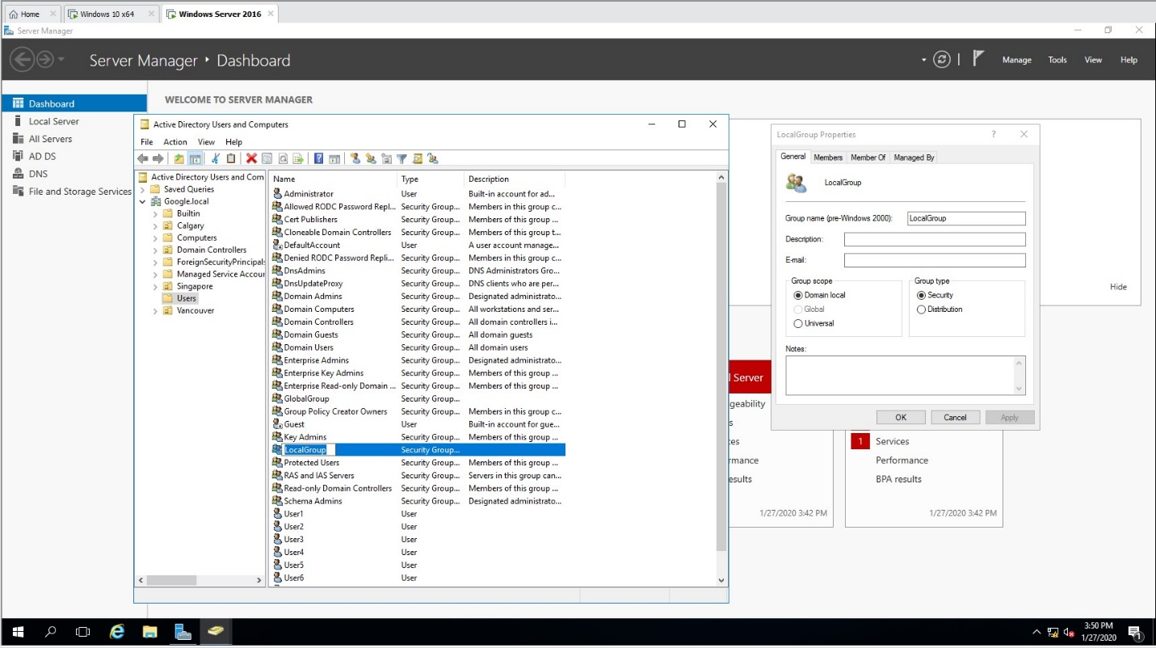
- Create another group
- Choose Global Security Group
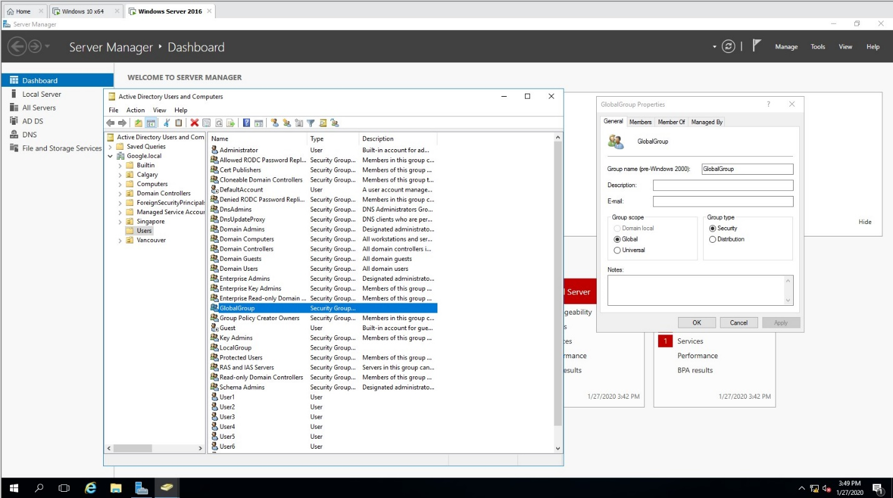
- Add two users in each one from what you have created in lab 3
